

Topic test 1
Name: __________________________________

Chapter 12: Graphs

• Time allowed: 45 minutes
• CAS calculators may be used.
• Part A: 7 multiple-choice questions (7 marks)
• Part B: 11 short answer questions (44 marks)
• Part C: 2 analysis questions (29 marks)

Part A
7 multiple-choice questions
1 mark each: 7 marks
Circle the correct answer.

1 The gradient of the line with the equation y = 5 − 2x is:
A 2
B 5
C
D 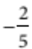
E −2

[1 mark]
2 Which of the following is not true for 3y = 9 + 6x?
A The line has a gradient of 6.
B The line is steeper than the line for the equation y = x.
C The point (1, 5) lies on the line.
D The line has a positive gradient.
E The line has a y-intercept of 3.

[1 mark]

3 The equation of the line with a gradient of 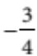 and a y-intercept of −1 is:
A 4x + 3y = −4
B 3x + 4y = −4
C 3x − 4y = −4
D 3x + 4y = 4
E 4x − 3y = 4

[1 mark]
4 The coordinates of the x- and y-intercepts respectively for the equation 7x − 2y = −28 are:
A (4, 0) and (0, −14)
B (−4, 0) and (0, 14)
C (−4, 0) and (0, −14)
D (7, 0) and (0, −2)
E (0, −4) and (14, 0)

[1 mark]
5 The coordinates of the point of intersection of the lines below are:
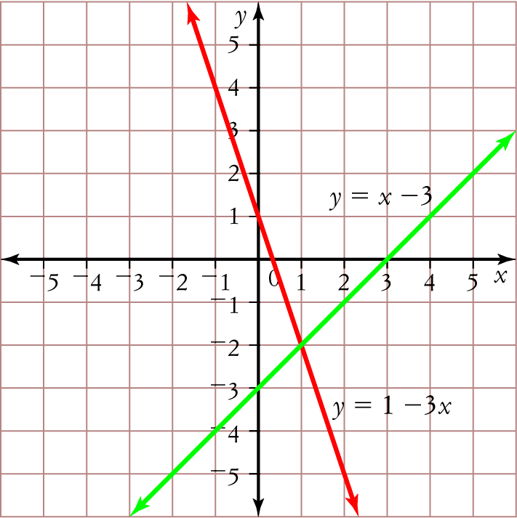
A (−1, 2) D (1, −2)
B (0, −3) E (1, 2)
C (3, 0)

[1 mark]
6 The solution to the simultaneous linear equations
y = 6x + 13
y − 2x = −7 is:
A x = 5, y = 3
B x = , y = −4
C x = −5, y = −17
D x = 5, y = −17
E x = −5, y = −4

[1 mark]
7 The step graph below shows the cost of sending a parcel to New Zealand by air.
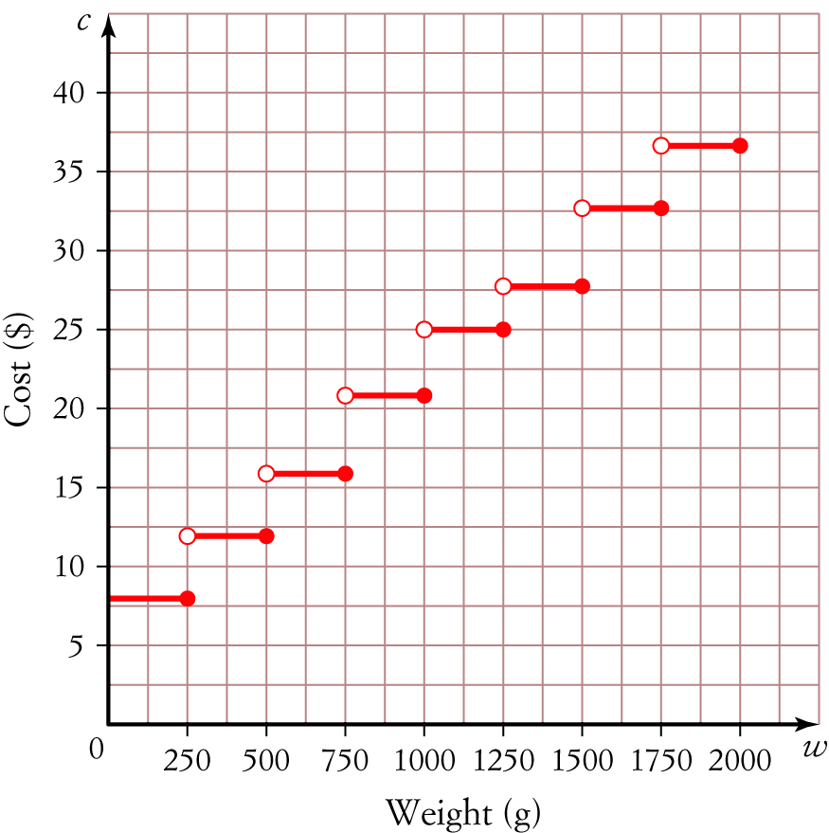
The total cost of sending a parcel weighing 500 g and a parcel weighing 1.6 kg is
A $45
B $33
C $37
D $12
E $45

[1 mark]

Part B
11 short answer questions
44 marks
Show your working where appropriate.
Where necessary give all answers to two decimal places.
1 Express the equation 3x + 8y − 18 = 0 in the form y = a + bx and hence state the gradient and
y-intercept of the line.

[3 marks]
2 Find the equation of the line passing through the points (−9, 5) and (0, 2).

[5 marks]
3 Determine the x- and y-intercepts of the equation 6x − 5y = 30 and hence sketch its graph.

[3 marks]
4 The graph shows the fees charged by an electrician.
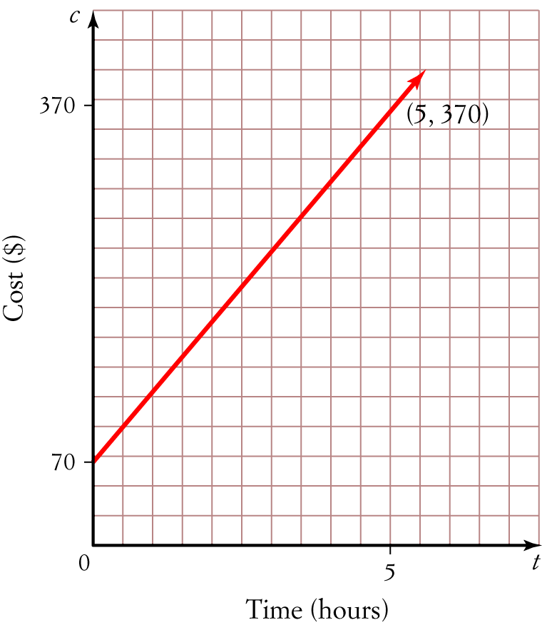
a What is the vertical intercept and what might it represent?

b State the gradient of the line.

c Write an equation for the line using your answers to parts a and b.

[4 marks]

5 Sketch the graphs of 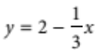 and x = 3 on the same set of axes. State the coordinates of their point
of intersection.

[4 marks]
6 Solve the simultaneous linear equations below using the substitution method.
y = −12 − 3x
y = 8 + 2x

[4 marks]
7 Use the process of elimination to solve the simultaneous linear equations:
5x + 3y = 6
3x + 4y = −3

[4 marks]
8 The sum of two numbers is 38 and their difference is 24.
a Write a pair of simultaneous linear equations to represent this information.

b Solve the equations simultaneously to find the two numbers.

[4 marks]

9 Sketch the graph of the stepwise linear equation below.
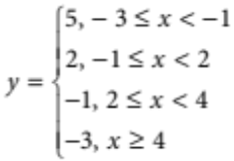

[3 marks]
10 A taxi driver charges $15 flag fall and $5 per kilometre or part thereof. Construct a step graph to represent the taxi driver’s charges for the first 6 kilometres.

[3 marks]
11 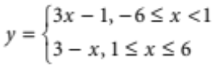
a How many line segments form this piecewise linear graph?

b What is the gradient of each line segment?

c Which line segment is steeper? Why?

d Sketch the graph of the piecewise linear equation given above.

[7 marks]
Part C
2 analysis questions
29 marks
Show your working where appropriate.
1 The piecewise linear graph below shows the volume of water in a water tank over 24 hours.
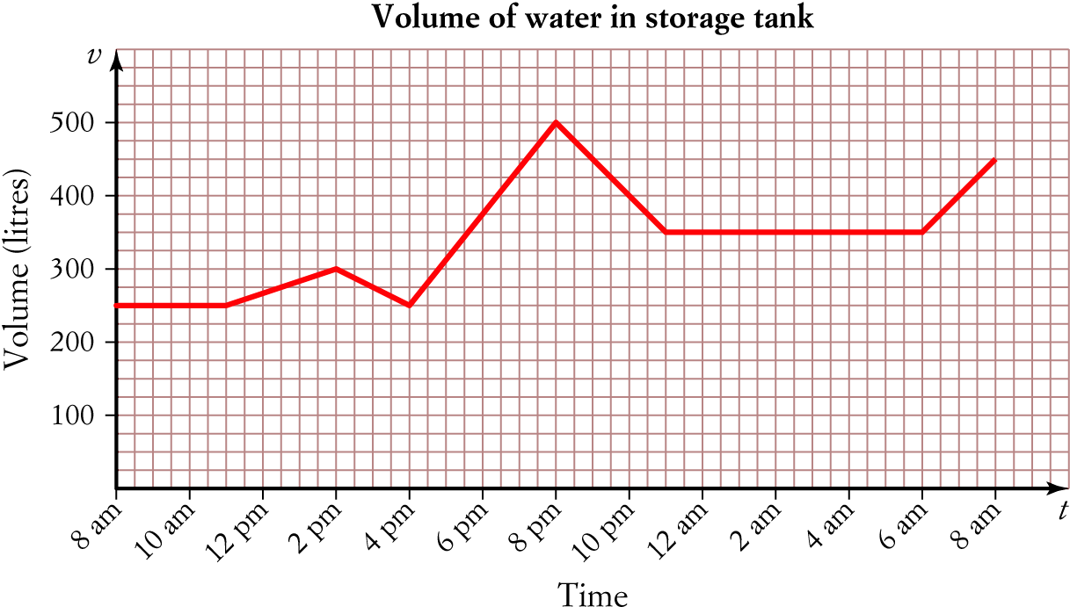
a What is the vertical intercept for this graph. What does this intercept represent?

b What is volume of water at
i 2 p.m.? ____________________________________
ii 5 a.m.? ____________________________________
iii 2 p.m.? ____________________________________
c At what time/s was the volume of water
i 500 litres? ____________________________________
ii 300 litres? ____________________________________
iii 100 litres? ____________________________________
d What is the difference in the volume of water in the tank between 2 p.m. and 12 a.m.?

e Between what time is the water tank filling the fastest? Explain your answer.

f Between what times is the level of water in the tank falling? Explain your answer.

g i What is the gradient of the line between 8 a.m. and 11 a.m.?

ii What does this tell us about the rate the water is filling between this time?

h Determine the gradient of the remaining line segments.

[18 marks]
2 Matthew owns a video rental store. His monthly costs of purchasing n new DVDs for his video shop is
C = 16n + 576, while his monthly income from renting out those new DVDs is I = 48n, where C and I
are in dollars.
a What is the vertical intercept of the Cost graph and what does it represent?

b Graph both functions for values of n from 0 to 40 and find the break-even point.

c What would happen if the store bought fewer DVDs than the break-even value of n?

d Calculate the monthly cost of purchasing 35 DVDs and the income earned from these.

e According to the formula, what monthly income is earned from each new DVD?

[11 marks]
Total marks: 80

Answers
Part A [1 mark each]
1 General form of an equation is y = a + bx, where a is the y-intercept and b = gradient.
For y = 5 − 2x, a = 5 and b = −2, therefore gradient = −2
∴ E
2 3y = 9 + 6x
y = 3 + 2x
y-intercept = 3, gradient = 2
A Not true: gradient of 3y = 9 + 6x is 2, not 6.
B True: 3y = 9 + 6x has a gradient = 2; y = x has a gradient = 1. 2 > 1, hence 3y = 9 + 6x is steeper
than y = x.
C True:
3  5 = 9 + 6  1
15 = 9 + 6
15 = 15 ✓
D True: gradient = +2
E True: y-intercept = 3
∴ A
3 a = −1, b =
Substitute a and b into y = a + bx.
y = −1 x
4y = −4 − 3x
3x + 4y = −4
∴ B
4 x-intercept: let y = 0
7x − 2 × 0 = −28
7x = −28
x = −4
Coordinates: ( −4, 0)
y-intercept: let x = 0
7 × 0 − 2y = −28
−2y = −28
y = 14
Coordinates: (0, 14)
∴ B
5 Locate the point of intersection (that is the point where the two lines cross). Read the coordinates from
the graph.
Coordinates are (1, −1)
∴ D
6 y = 6x + 13 [1]
y − 2x = − 7 [2]
Substitute [1] into [2]
6x + 13 − 2x = −7
4x + 13 = −7
4x = −20
x = −5
Substitute x = −5 into [1]
y = 6 × −5 + 13
y = −30 + 13
y = −17
Solution is x = −5, y = −17
∴ C
7 The 500 g parcel will cost $12 to send.
The 1.6 kg (1600 g) will cost $33 to send.
Total cost = $12 + $33
= $45
∴ A
Part B
1 3x + 8y − 18 = 0
8y = 18 − 3x
y = − x [1 mark]
a = , b = − [1 mark]
∴ gradient = −, y-intercept = [1 mark]
2 Let (x₁, y₁) = (−9, 5) and (x₂, y₂) = (0, 2)
b = 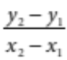
= 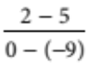 [1 mark]
= −
= − [1 mark]
(0, 2) are the coordinates of the y-intercept.
∴ a = 2 [1]
Substitute a = 2 and b = −into y = a + bx
y = 2 −x [1 mark]
3y = 6 − x
x + 3y = 6 [1 mark]
3 Let x = 0, 6 × 0 − 5y = 30
−5y = 30 [1 mark]
y = −6
Let y = 0, 6x − 5 × 0 = 30
6x = 30 [1 mark]
x = 5

x-intercept = 5, y-intercept = −6
Plot the x- and y-intercepts.
Join these points to sketch the line. Extend the line.
Remember to write the equation of the line next to its graph.
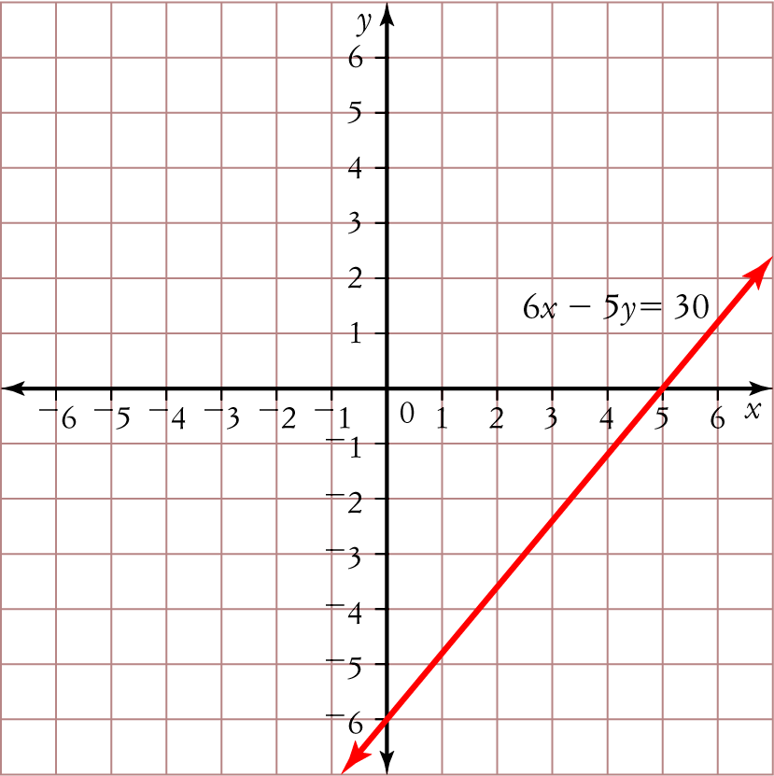
[1 mark]
4 a $70; Vertical intercept represents the call out fee for the electrician. [1 mark]
b gradient =
= 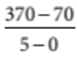 [1 mark]
= 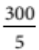
= 60 [1 mark]
c Equation will be in the form y = a + bx, where a = 70 and b = 60.
∴ C = 70 + 60t [1 mark]
5 The equation 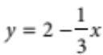 is written in the form y = a + bx. Use the gradient and y-intercept method to
sketch its graph.
gradient = − y-intercept = 2 [1 mark]
The equation x = 3 is in the form x = a. There is no y-value present in the equation; hence the graph is a
line parallel to the y-axis. The x-intercept is 3. [1 mark]
Sketch both lines on the same set of axes.

Remember to write the equation of the line next to its graph.
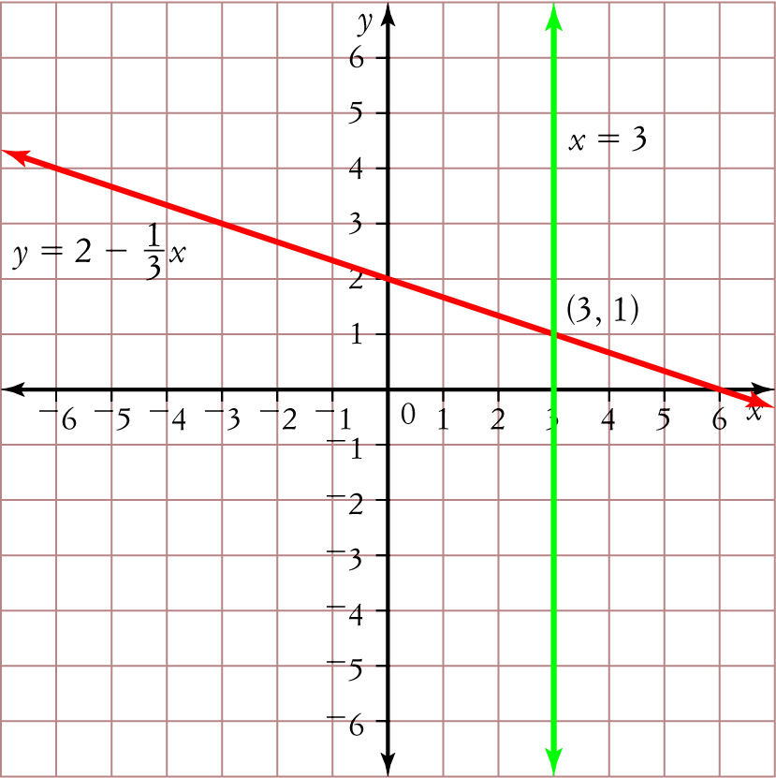
[1 mark]
Point of intersection is (3, 1). [1 mark]
6 y = −12 − 3x [1]
y = 8 + 2x [2]
Substitute [1] into [2]
−12 − 3x = 8 + 2x [1 mark]
−12 = 8 + 5x
−20 = 5x
x = −4 [1 mark]
Substitute x = −4 into [2]
y = 8 + 2 × −4
y = 0 [1 mark]
Check the answer.
[1] 0 = −12 − 3 × −4
0 = −12 + 12 ✓
[2] 0 = 8 + 2 × −4
0 = 8 − 6 ✓
The solution is x = −4 and y = 0. [1 mark]
7 5x + 3y = 6 [1]
3x + 4y = −3 [2]
[1] × 4 20x + 12y = 24 [3]
[2] × −3 − 9x − 12y = 9 [4] [1 mark]
[3] + [4] 11x = 33
x = 3 [1 mark]
Substitute x = 3 into [1]
5 × 3 + 3y = 6
15 + 3y = 6
3y = −9
y = −3 [1 mark]
The solution is x = 3 and y = −3. [1 mark]
8 a Let x = first number and y = second number
x + y = 38
x − y = 24 [1 mark]
b x + y = 38 [1]
x − y = 24 [2]
[1] + [2]
2x = 62
x = 31 [1 mark]
Substitute x = 31 into [1]
31 + y = 38
y = 7 [1 mark]
The two numbers are 31 and 7. [1 mark]
9 There are 4 line segments (or steps) to the graph.
Draw a horizontal line from −3 to −1 at 5. −3 is included but −1 is not, so place a closed circle at the start and an open circle at the end of the segment.
Draw a horizontal line from −1 to 2 at 2. −1 is included but 2 is not, so place a closed circle at the start and an open circle at the end of the segment.
Draw a horizontal line from 2 to 4 at −1. 2 is included but 4 is not, so place a closed circle at the start and an open circle at the end of the segment.
Draw a horizontal line starting from 4 at −3. 4 is included, so place a closed circle at the start of the line and an arrow at the end to show that the line continues to infinity.
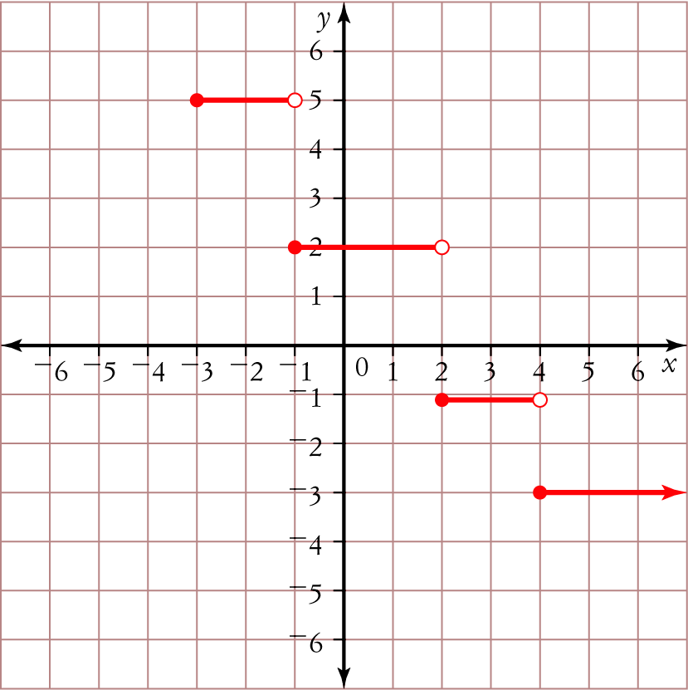

[1 mark for placing line segments in correct position]
[1 mark for placing open/closed circles/arrow correctly at end of line segments]
[1 mark for presentation of graph/ labelling etc.]
10 Horizontal axis labelled d (distance), with scale increasing by 1 from 1 to 5.
Vertical axis labelled $C (cost), with scale increasing by 2 from 0 to 50. [1 mark]
Vertical intercept = 20 [1 mark]
Line segments drawn correctly with open circles at start and closed circles at end. [1 mark]
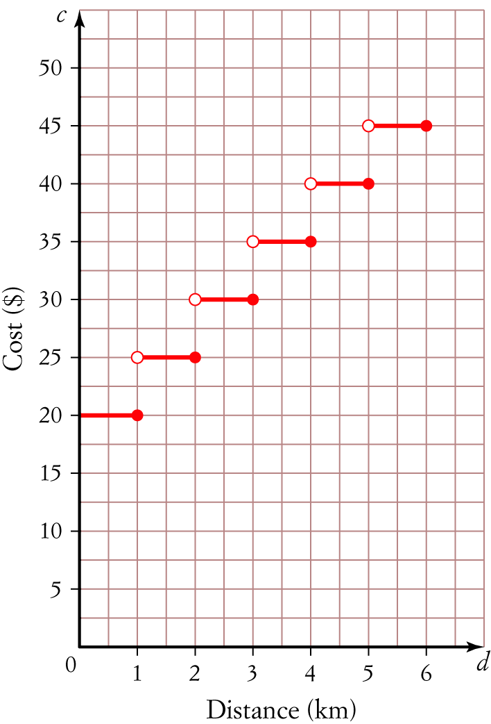
11 a line segments [1 mark]
b y = 3x − 1; gradient = 3
y = 3 − x; gradient = −1 [1 mark]
c y = 3x − 1 is steeper. [1 mark]
It has a gradient of 3 compared to −1. The larger the gradient the steeper the line. [1 mark]
d Sketch y = 3x − 1 for x-values between −6 and 1.
gradient = 3, y-intercept = −1
End points are:
x = −6, y = 3 × −6 − 1
y = −19
(−6, −19)
x = 1, y = 3 × 1 − 1
y = 2 [1 mark]
(1, 2)
Sketch y = 3 − x for x values between 1 and 6.
gradient = −1, y-intercept = 3
x = 1, y = 3 − 1
y = 2
(1, 2)
x = 6, y = 3 − 6
y = −3 [1 mark]
(6, −3)
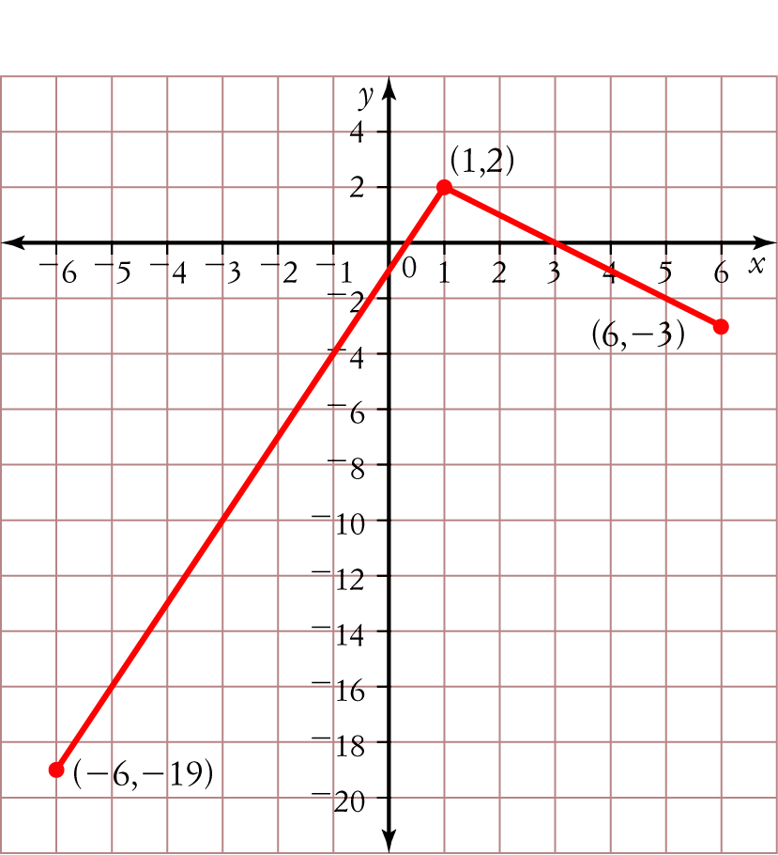
[1 mark for labelling/presentation/scale]

Part C
1 a 250 litres [1 mark]
Level of water in the tank at 8 a.m., that is when level of water is first measured. [1 mark]
b i 300 litres
ii 350 litres
iii 265 litres
[1 mark + 1 mark + 1 mark = 3 marks]
c i 8 p.m.
ii 2 p.m. and 5 p.m.
iii Water levels did not fall to 100 litres.
[1 mark + 1 mark + 1 mark = 3 marks]
d Water level at 2 p.m. = 300 litres; water level at 12 a.m. = 350 litres
Difference = 350 − 300
= 50 litres [1 mark]
e Between 4 p.m. and 8 p.m. [1 mark]
The gradient is the steepest between these times. [1 mark]
f Between 2 p.m. and 4 p.m. and between 8 p.m. and 11 p.m. [1 mark]
The gradient is negative, hence the water levels are falling. [1 mark]
g i gradient = 0 [1 mark]
ii Water levels did not change during this time, i.e. rate is 0 litres/hour. [1 mark]
h Between 11 a.m. and 2 p.m. gradient = 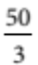
Between 2 p.m. and 4 p.m. gradient = −25
Between 4 p.m. and 8 p.m. gradient = 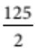
Between 8 p.m. and 11 p.m. gradient = −50
Between 11 p.m. and 6 a.m. gradient = 0
Between 6 a.m. and 8 a.m. gradient = 50 [3 mark]
2 a 576, the fixed cost in dollars of buying new DVDs. [1 mark]
b C = 16n + 576; Vertical intercept = 576, gradient = 16 [1 mark]
I = 48n; Vertical intercept = 0, gradient = 48 [1 mark]
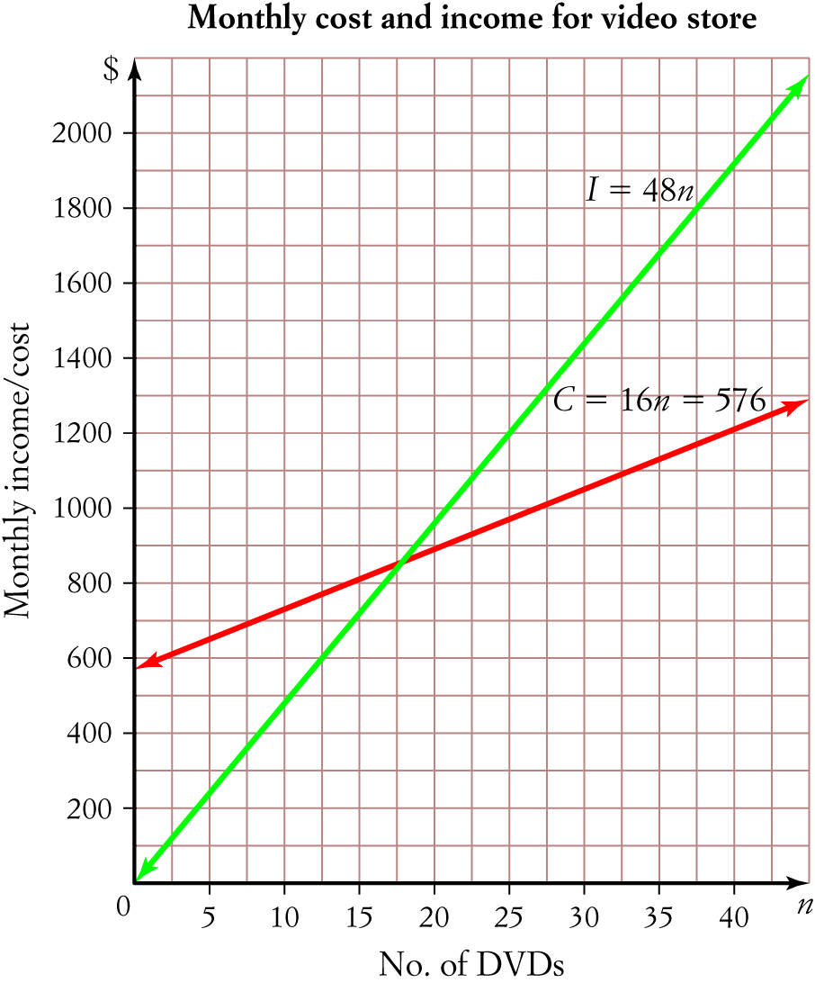
[1 mark for labelling and accuracy of graph]
Break-event point: (18, 864) [1 mark]
c They would make a loss: the monthly cost would be more than the monthly income. [1 mark]
d C = 16n + 576
C = 16 × 35 + 576
C = 1136 [1 mark]
I = 48n
I = 48 × 35
I = 1680 [1 mark]
Monthly cost = $1136, Monthly income = $1680
[1 mark + 1 mark = 2 marks]
e I = 48n, Gradient is 48, therefore each DVD will earn $48 per month.
[1 mark]

